อักษรย่อกระบวนวิชา | 331507
ชื่อ สกุล
ชนิดข้อสอบ | MCQ
ระดับข้อสอบ
เกณฑ์แพทยสภา
ข้อความตามเกณฑ์
แหล่งอ้างอิง

A 55-year-old male had neck pain for a year. He gradually developed hand clumpsiness and difficulty walking. Physical examination demonstrated spastic paralysis of both hands and lower extremities, hand numbness, hyperreflexia and positive Hoffman's sign. Neck motion and cranial nerve function was normal. X-ray and MRI showed as Figures. What is the most appropriate treatment for the patient?
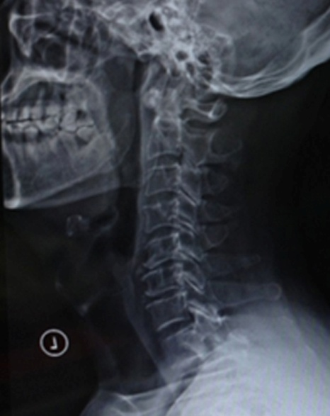

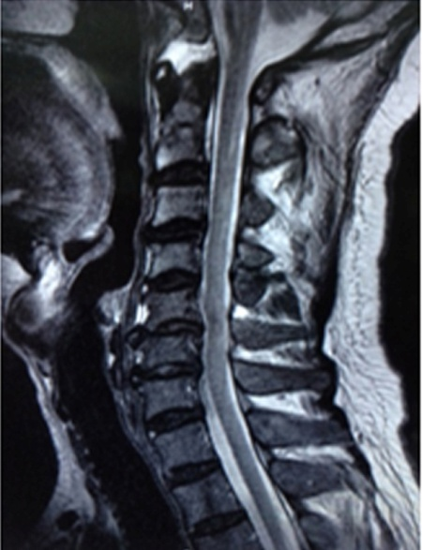

A | Anti-inflammatory & Pain Medications
B | Continuous physiotherapy and rehabilitation
C | Scheduling for electrodiagnostic studies
D | Elective anterior decompression & fusion
E | Closed observation for every months.

CORRECT ANSWER | D

KEYWORD

